# **AUTOMATION TESTING ON LINKEDIN WEBSITE**

## **EPAM FINAL TEAM PROJECT REPORT**

**Submitted to**

**LOVELY PROFESSIONAL UNIVERSITY**

**PHAGWARA, PUNJAB**



**Course Name: - Industry Internship Project**

**Course Code: - CSE441**

**Group no: - 01**

**Submitted by:**

**Chellaboina Raghavendra: 11908278**

**Bobba Sairam: 11906043**

**Arjun Bachawar: 11910533**

**List of Contents**

|  |  |  |
| --- | --- | --- |
| S. No | Description | Page. No |
| 1. | Chapter-1 (INTRODUCTION OF THE COMPANY) | 03 |
| 2. | Chapter-2 (INTRODUCTION OF THE PROJECT UNDERTAKEN) | 07 |
| 3. | Chapter-3 (TABLE OF CONTENT) | 09 |
| 4. | Chapter-4 (PROCESS UNDERGONE WHILE DOING PROJECT) | 31 |
| 5. | Chapter-5 (FINAL INDIVIDIUAL TASK) | 32 |
| 6. | Chapter-6 (KNOWLWDGE AND SKILLS LEARNED IN EPAM) | 37 |
| 7. | Chapter-7 (FINAL CHAPTER) | 41 |

# **GitHub links**

1.Final Group Project link: - https://github.com/Sairam9100/EPAM_TEAM_PROJECT

2.Final Individual task: - https://github.com/Sairam9100/EPAM_MODULE_2

# **Chapter-1: -**

## **INTRODUCTION OF THE COMPANY**

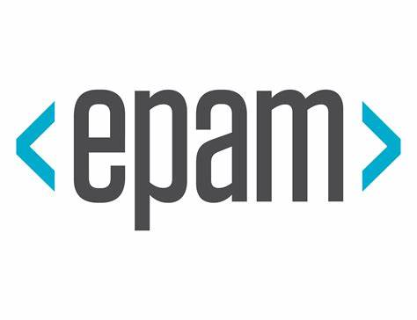

Epam Company is an IT services and digital solutions provider with a global workforce. Founded in the United States in 1993, they have expanded to offer their services in over 40 countries and regions. In 2020, they were ranked as the top IT services company on Fortune’s 100 Fastest-Growing Companies list, jumping 50 positions to #21. The following year, they recorded their first billion-dollar revenue quarter and were added to the S&P 500. EPAM consistently delivers powerful digital solutions to their customers and is specialized in 11 industries. Customers can rely on their experienced and skilled teams of technologists, strategists and designers who deliver innovative solutions. Founded with the mission of becoming the best, EPAM continues to develop and provide valuable solutions that meet their customer’s needs. Epam Company offers a wide range of services and solutions to their clients.

As a leading technology solutions provider, they specialize in custom software engineering, providing access to world-class resources and expertise. From designing mobile and web products to delivering powerful digital experiences, Epam has become a trusted partner in delivering innovative solutions to difficult problems for customers in over 50 countries and 11 industries. Partnering with Epam offers businesses a few key benefits, including access to experienced professionals and cost savings. Their teams of experienced technologists, strategists, and designers can collaborate with your internal teams to develop solutions tailored to your business. Additionally, Epam is a publicly traded company with a forward P/E ratio of 25 and a PEG ratio of 0.56, making them a cost-effective option for long-term partners. Furthermore, Epam facilitates collaboration with leading technology and platforms. They have partnered with biotech to “make insurance easy” for customers in more than 30 countries globally. This partnership offers businesses the opportunity to leverage the technological capabilities of two leading companies to develop tailored solutions and deliver efficient products.

In summary, Epam Company provides a wide range of services and solutions to businesses in over 50 countries. Their teams of experienced professionals, cost-saving strategies, and partnerships with leading technologies and platforms make them an ideal partner for businesses seeking to develop innovative solutions. EPAM Systems, a global software engineering services company, was founded in 1993 by Arkadiy Dobkin and Leo Lozner. The company was born when the two founders met again in grade school more than 20 years later. The headquarters are in New Jersey, USA and Minsk, Belarus with a global presence.

During their early days, EPAM was ranked as a fast-growing company by Deloitte & Touche in 2002. This distinction made EPAM the first Russian player on the London Stock Exchange. EPAM has continued to skyrocket since then becoming one of the strongest brands in the industry. Their repeatable model of success has provided clients with high quality results at scale and EPAM has become an increasingly sticky partner. In 2021, EPAM achieved an industry leading reported growth rate of 41.3%. Their integrated consulting services, agile approach and engineering heritage has propelled the company to their current success. EPAM views customer success as their own success and is constantly striving to provide clients with the best possible service.

Their impact on clients, the industry, and the global economy is evident. EPAM is truly an inspiring company that has changed the game for many, epam is dedicated to making its communities better places to live through its charitable initiatives. The company empowers its employees to lead socially responsible education, environmental, and community initiatives. Epam is actively involved in the cities around it, the tech community, and many global social programs. It collaborates with many partners to do good in the world. It supports Ukraine with humanitarian aid, which is just one example of the company’s charitable efforts. One of EPAM's core strengths is its ability to deliver high-quality software development services. The company's team of experienced software engineers are skilled in a wide range of programming languages and technologies, including Java, Python, JavaScript, and .NET. EPAM's development services cover the entire software development lifecycle, from requirements gathering and design to development, testing, and deployment.

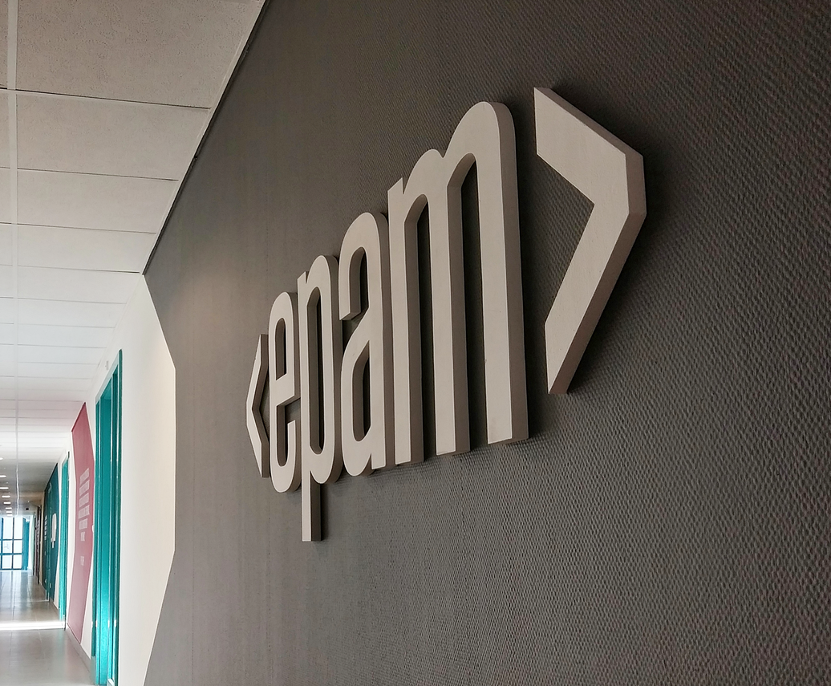

In addition to software development, EPAM also offers digital strategy consulting services to help its clients define their digital strategy and transform their businesses. EPAM's consultants work closely with clients to identify their business goals and develop a digital roadmap that aligns with those goals. The company's expertise in areas such as customer experience design, digital marketing, and e-commerce enables it to deliver digital strategies that drive business growth and improve customer engagement. EPAM is also a leader in user experience design.

The company's UX designers work closely with clients to create intuitive, engaging user experiences that improve customer satisfaction and drive business results. EPAM's designers use a variety of tools and methodologies, including user research, prototyping, and user testing, to ensure that the user experience is optimized for each client's unique needs. Another area of expertise for EPAM is data science and analytics. The company's data scientists are skilled in areas such as machine learning, predictive modelling, and data visualization. EPAM's analytics services help clients to extract insights from their data and make data-driven decisions that drive business growth. Epam also has its own social responsibility programs that it runs, such as eKids. The eKids program is designed to support youth development and build valuable skills for children in need around the world. Epam also won a Global PR Award in the Program of the Year category for this program.

Finally, Epam encourages social innovation among the tech community and encourages learning and sharing. Epam promotes skills, inclusion, and diversity, and encourages its employees to think outside the box to make positive change. With its commitment to community, Epam will continue to find ways to give back and make the world a better place. EPAM is expanding on the Sustainability Cloud solution which is tied to another transformation trend, “total experience.” Founded by Belarusians Arkadiy Dobkin in New Jersey, and Leo Lozner in Minsk on a partnership basis in 1993, EPAM has grown to a billion-dollar revenue company with 40 countries and regions as clients.

**Various departments and their functions: -**

1. Delivery Management: The delivery management department is responsible for overseeing project delivery, ensuring that projects are delivered on time, within budget, and to the client's satisfaction. The department is responsible for project planning, resource allocation, risk management, and quality control.
2. Engineering: The engineering department is responsible for designing and developing digital platforms and software solutions. The department includes software engineers, architects, and designers who use the latest technologies and tools to develop cutting-edge solutions.
3. Quality Assurance: The quality assurance department is responsible for ensuring that EPAM's products and services meet the highest quality standards. The department is responsible for testing software, identifying and reporting defects, and providing feedback to the engineering department to improve the quality of EPAM's products.
4. Business Analysis: The business analysis department is responsible for analysing clients' business needs and translating them into technical requirements. The department works closely with clients to understand their business processes, identify pain points, and recommend solutions that improve efficiency and productivity.
5. Sales: The sales department is responsible for identifying new business opportunities, developing relationships with potential clients, and closing deals. The department includes sales representatives, account managers, and business development managers who work closely with clients to understand their needs and propose solutions that meet their requirements.
6. Marketing: The marketing department is responsible for promoting EPAM's products and services to potential clients. The department includes digital marketers, content creators, and event planners who use various channels, such as social media, email marketing, and events, to raise awareness of EPAM's offerings.
7. Human Resources: The human resources department is responsible for recruiting, training, and retaining EPAM's employees. The department is responsible for creating a positive work environment, developing employee skills, and providing competitive compensation and benefits packages.
8. Finance: The finance department is responsible for managing EPAM's financial resources, including budgeting, forecasting, and financial reporting. The department is responsible for ensuring that EPAM's financial performance is healthy and sustainable.
9. Legal: The legal department is responsible for ensuring that EPAM's operations comply with legal and regulatory requirements. The department includes lawyers and legal specialists who provide advice and support on legal matters, such as contracts, intellectual property, and data protection.
10. Operations: The operations department is responsible for managing EPAM's infrastructure and facilities. The department includes IT specialists, facilities managers, and logistics coordinators who ensure that EPAM's operations run smoothly and efficiently.
11. Innovation: The innovation department is responsible for exploring new technologies and trends and identifying opportunities to apply them to EPAM's products and services. The department includes researchers, designers, and strategists who work on developing new ideas and approaches that can help EPAM stay ahead of the competition and offer cutting-edge solutions to its clients.
12. Global Business Units: EPAM has several global business units (GBUs) that specialize in different industries and domains. The GBUs include healthcare, financial services, travel and hospitality, retail and distribution, media and entertainment, and software and high-tech. Each GBU has a team of experts who understand the specific challenges and opportunities in their respective industries and provide customized solutions to clients.
13. Talent Development: The talent development department is responsible for developing EPAM's employees' skills and capabilities. The department includes trainers, coaches, and mentors who provide training programs, certifications, and career development opportunities to help employees grow and advance their careers within the company.
14. Customer Experience: The customer experience department is responsible for ensuring that EPAM's clients have a positive experience working with the company. The department includes customer success managers, customer support specialists, and account managers who work closely with clients to understand their needs and provide solutions that meet their requirements.
15. Cybersecurity: The cybersecurity department is responsible for ensuring that EPAM's products and services are secure and protected from cyber threats. The department includes cybersecurity experts who identify and mitigate potential vulnerabilities, provide security assessments and audits, and develop cybersecurity strategies and policies.
16. Cloud and Infrastructure: The cloud and infrastructure department is responsible for managing EPAM's cloud-based infrastructure and ensuring that it is scalable, reliable, and secure. The department includes cloud architects, DevOps engineers, and infrastructure specialists who use the latest cloud technologies and tools to provide optimal solutions for EPAM's clients.
17. Data Science and Analytics: The data science and analytics department is responsible for analysing data and providing insights that help clients make informed decisions. The department includes data scientists, analysts, and engineers who use advanced analytics tools and technologies to extract value from data and provide actionable insights.
18. Product Management: The product management department is responsible for defining and managing EPAM's product portfolio. The department includes product managers, product owners, and product marketing specialists who work closely with clients and the engineering department to develop and launch new products and features that meet market needs.

It has also been included in the Forbes Global 2000 list and added to the S&P 500 with a Governance Quality Score of 9 out of 10. Moreover, the company has been hailed a leader in the technology industry for its achievements in artificial intelligence, virtual reality, Internet of Things, and has demonstrated a commitment to customer service and long-term customer relationships. Epam has also launched initiatives dedicated to sustainability, diversity and inclusion, training programs and internships which offers opportunities for entrepreneurs and new graduates to acquire professional experience in the technology field. In doing so, they have produced positive effects that are beneficial to individuals, organizations, and the industry.

# **Chapter-2: -**

## **INTRODUCTION OF THE PROJECT UNDERTAKEN**



LinkedIn is a social networking platform designed for professionals and businesses. It was founded in 2002 and has since grown into the world's largest professional network with over 750 million members in more than 200 countries and territories. One of the primary functions of LinkedIn is to allow users to create professional profiles that showcase their skills, education, work experience, and other relevant information. These profiles serve as an online resume and can be used to connect with other professionals, potential employers, and business partners.

LinkedIn also offers a variety of networking tools that make it easy to connect with other professionals in your field. Users can search for and connect with other professionals based on their industry, job title, location, and other criteria. LinkedIn also provides recommendations and endorsements, allowing users to showcase their skills and expertise to potential employers and business partners. In addition to networking tools, LinkedIn also offers a range of resources for professional development. These include online courses, webinars, and other educational resources that can help users improve their skills and advance their careers. LinkedIn Learning, for example, offers thousands of online courses taught by industry experts in fields such as technology, business, and creative arts.

LinkedIn also serves as a platform for businesses to connect with potential customers and partners. Companies can create business pages on LinkedIn that showcase their products and services and provide a way for users to follow their updates and news. LinkedIn also offers advertising tools that allow businesses to target specific audiences based on their industry, job title, and other criteria. LinkedIn is a powerful social networking platform for professionals and businesses. With its focus on professional development, networking, and business connections, it provides a valuable resource for anyone looking to advance their career or grow their business. As the world's largest professional network, LinkedIn is an essential tool for anyone looking to succeed in today's rapidly changing business environment.

The first step in testing LinkedIn is to login to a profile. Your profile should include a professional headshot, a detailed summary of your experience and skills, and a list of your current and past positions. It is also important to include links to any relevant websites or publications, as well as any awards or certifications you may have earned. Additionally, you should make sure to include keywords that are relevant to your industry, as this will help potential employers and colleagues find you more easily.

Once you are logged into your profile, it is time to start connecting with other professionals. LinkedIn allows you to search for people by name, company, or industry, and you can also join groups related to your field. This is a great way to find potential employers, colleagues, and industry experts. Additionally, you can use LinkedIn’s messaging feature to reach out to people you are interested in connecting with.



Finally, it is important to stay active on LinkedIn. You should regularly post updates about your work, share relevant articles, and comment on other people’s posts. This will help you stay connected with your network and will ensure that you remain visible to potential employers and colleagues.



In conclusion, testing LinkedIn is an essential part of any professional’s online presence. By creating a detailed profile, connecting with other professionals, and staying active on the platform, you can maximize your professional network and increase your chances of success in test cases.

# **Chapter-3: -**

## **TABLE OF CONTENT**

1. Scope 5
2. Application Overview 5
3. Test Approach 6
4. Test Types 6
5. Roles and Responsibilities 7
6. Environment Requirements 8
7. Testing Tools 8
8. Industry Standards to follow 8
9. Test deliverables 10
10. Risk and mitigation 14
11. Reporting tool 14
12. Test summary 14
13. Approvals 14

**1.SCOPE: -**

LinkedIn is mainly known for world’s largest social network platform which is competing with giants like Facebook, Twitter and Instagram etc. This online platform provides a 24×7 service, that is users can update their professional skills and search for a job which is suitable for their skills. It is also referred to as the best and well known platform for job search.

**Functional Requirements:**

* The main page consists of Logo of Application, Sign In/Join now page, Jobs page, People page, profile page, Discover page and helpline details under the bottom of Home page.
* The page consists of options such as Contact info, Message and Search. There is an option to message another user by entering their username in search box and message.
* The page Consists of the user information, message delete feature, Sign out option for signing out.

**Non-Functional Requirements:**

* Capturing the behaviour when many people are using the software at the same time. Most of the time it is experienced that the users are currently not hiring anyone.
* Validates that the system meets the expected response time. Evaluates that the significant elements of the application meet the desired response time.
* Whether the Application easy to use.

**2.OVERVIEW**: -  
 Online job search applications have become increasingly popular in recent years, with many job seekers using them to find new employment opportunities. These applications offer a range of features and tools that can help job seekers streamline their search and increase their chances of finding the right job. Some of the most common uses of online job search applications include updating resumes and profiles on professional networking platforms, using keywords to search for jobs, using job search engines and company websites to find open positions, and being selective in the jobs applied for. Additionally, some online job search applications use AI to help job seekers optimize their chances of matching with the right job. It's also important for job seekers to be aware of applicant tracking systems (ATS), which are used by many companies to automate the hiring process. By understanding how to use online job search applications effectively and navigate ATS, job seekers can increase their chances of finding the right job and advancing their careers.

**https://www.linkedin.com/home**



**3.TEST APPROACH: -**

* Test levels
* Test types
* Roles and responsibilities
* Environment requirements (hardware and software requirements).

**4.TEST LEVELS: -**

During the testing process the testers tested application in various levels. Such as, Unit testing, Integration testing, system testing and user acceptance testing.

**Test Types:**

* **FUNCTIONAL TESTING:**

Functional testing involves testing the functionality of the website to ensure that it works as intended. This type of testing can be used to test the login page, message, and sign out components of a website. Functional testing can help identify issues such as incorrect login credentials, error messages, and other functional issues.

* **USABILITY TESTING:**

Usability testing is defined as the evaluation of a product by testing it on potential users. To test how users will add multiple items in the cart. Is it easy for them to set the prices in their desired currency? Can they choose their preferred payment method without any hassle? if users can pick the payment methods they want, you can evaluate whether the website shows payment methods valid for the user’s country.

* **INTERFACE TESTING:**

UI testing involves testing the user interface of the website to ensure that it is user-friendly and easy to navigate. This type of testing can be used to test the login page, message, and sign out components of a website. UI testing can help identify issues such as broken links, missing buttons, and other user interface issues.

* **COMPACTIBILITY TESTING:**

It helps avoid issues related to versions updates, navigation flows, screen size adaptation, broken tables, frames, etc.  and the testing will be done in

* Testing on PC, on different browsers like Safari, Chrome, Firefox, IE.
* Testing on different mobile devices that have different platforms like iOS, Android, or Windows.
* Testing on networks like 4G, 3G or Wi-Fi.
* Testing on multiple operating systems such as Mac, Windows, Linux.
* **PERFORMANCE TESTING:**

Performance Testing is that type of software testing that pinpoint on how a system is running under a particular circumstance. Performance testing measures depending on the benchmarks and standards. Performance testing helps the developers to eliminate the bottlenecks. Performance of a mobile or a web application is basically its capability of performing all the functions which it is supposed to do flawlessly without causing any delay or complication. its primary work, such as loading pages, showing the products, bringing out proper search results for the viewers, and loading the pages on time as well.

**5.ROLES AND RESPONSIBILITIES: -**

* We are responsible for identifying defects, bugs, and other issues in software and reporting them to the development team.
* We work closely with developers to ensure that issues are resolved, and that the software meets the requirements and specifications.
* Managing the changes and executing regression tests.
* Testers are also responsible for creating and executing test plans, test cases, and test scripts to ensure that the software is thoroughly tested.
* Interacting with customers/clients to solve the various issues they face and updating on the situation.
* Automating the design of a framework.
* Implementing it as per the structure of the project.
* Creating an automation test plan and getting approval.
* Identifying and selecting the automation test cases.
* Applying various designs and documenting the automation test strategy.
* Configuring Selenium Test Environment (STE) to set it up.
* Participating in Selenium Environment Setup with an Integrated Development Environment (IDE).

**6. ENVIRONMENT REQUIREMENTS: -**

**Software Environment:**

* Operating System- windows
* Java development toolkit.

**Hardware Environment:**

* Processor: Dual Core
* RAM: 2GB
* Hard disk: 512GB.

**7.TESTING TOOLS: -**

Software Requirements:

* Selenium Testing tool.
* Jenkins
* Operation system- Windows.

Hardware Requirements:

* Processor: Intel Core i5
* RAM: 6GB
* Hard disk: 512GB

**8.INDUSTRY STANDARDS USED: -**

* [**IEEE 1008-1987 - IEEE Standard for Software Unit Testing**](https://standards.ieee.org/standard/1008-1987.html)

An integrated approach to systematic and documented unit testing is defined. It uses unit design and unit implementation information, in addition to unit requirements, to determine the completeness of the testing. The testing process described composed of a hierarchy of phases, activities, and tasks and defines a minimum set of tasks for each activity. The standard can be applied to the unit testing of any digital computer software or firmware and to the testing of both newly developed and modified units.

* [**IEEE/ISO/IEC 29119-2-2013 - ISO/IEC/IEEE International Standard - Software and systems engineering —Software testing —Test processes**](https://standards.ieee.org/standard/29119-2-2013.html)

The purpose of the ISO/IEC/IEEE 29119 series of software testing standards is to define an internationally agreed set of standards for software testing that can be used by any organization when performing any form of software testing. ISO/IEC/IEEE 29119-2 comprises test process descriptions that define the software testing processes at the organizational level, test management level and dynamic test levels. It supports dynamic testing, functional and non-functional testing, manual and automated testing, and scripted and unscripted testing. The processes defined in ISO/IEC/IEEE 29119-2 can be used in conjunction with any software development lifecycle model. Since testing is a key approach to risk-mitigation in software development, ISO/IEC/IEEE 29119-2 follows a risk-based approach to testing. Risk-based testing is a common industry approach to strategizing and managing testing. Risk-based testing allows testing to be prioritized and focused on the most important features and functions.

* [**IEEE/ISO/IEC 29119-3-2013 - ISO/IEC/IEEE International Standard - Software and systems engineering — Software testing —Test documentation**](https://standards.ieee.org/standard/29119-3-2013.html)

The purpose of the ISO/IEC/IEEE 29119 series of software testing standards is to define an internationally agreed set of standards for software testing that can be used by any organization when performing any form of software testing. ISO/IEC/IEEE 29119-3 includes templates and examples of test documentation. The templates are arranged within clauses reflecting the overall test process description structure in ISO/IEC/IEEE 29119-2, i.e., by the test process in which they are being produced. Annex A contains outlines of the contents of each document. Annex B contains mappings ISO/IEC/IEEE 29119-2. Annex C contains an overview of the examples. Annexes D to S contain examples of the application of the templates. Annex T provides mappings to existing standards. The Bibliography for this part of ISO/IEC/IEEE 29119 is at the end of the document. ISO/IEC/IEEE 29119-3 supports dynamic testing, functional and non-functional testing, manual and automated testing, and scripted and unscripted testing.

**9.TEST DELIVERABLES: -**

* Test Scenario
* Test cases and data
* Requirement traceability matrix.
* Test summary report
* Test closure report

**9.1 Test Scenarios for Online Social web application:**

|  |  |  |
| --- | --- | --- |
| SN | Test scenario ID | Test Objective/Test scenarios |
| 1 | With no credentials Test | User doesn’t exist in the database. |
| 2 | With invalid credentials Test | Invalid credentials are used to test. |
| 3 | With valid credentials Test | Login to home page with correct credentials test. |
| 4 | Test Contact info | Selecting the profile button and click on contact info. |
| 5 | Edit Contact info Test | Edit the details and click on save. |
| 6 | Search Box Test | Click on search box and enter a profile name. |
| 7 | Message Test | Click on message icon and send a message. |
| 8 | Delete message Test | Click on checkbox and delete the message. |
| 9 | Sign out Test | Go to me and Sign out. |

**9.2 Test cases Data:**

**1.** With no credentials Test: -



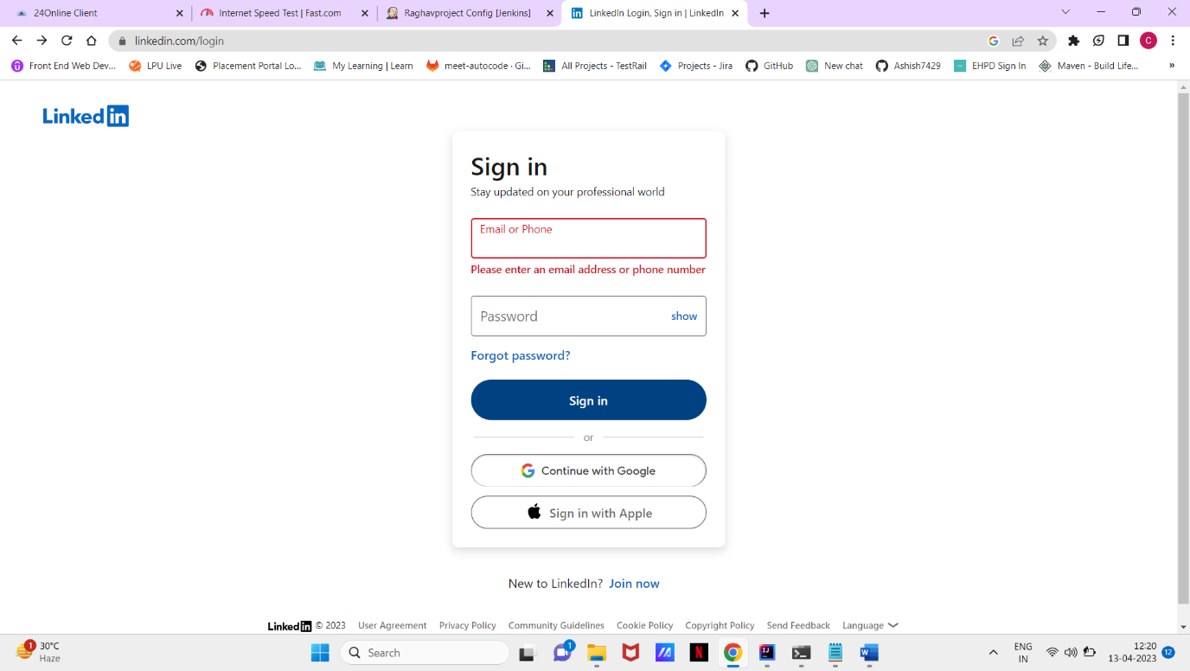

**2.** With invalid credentials Test: -



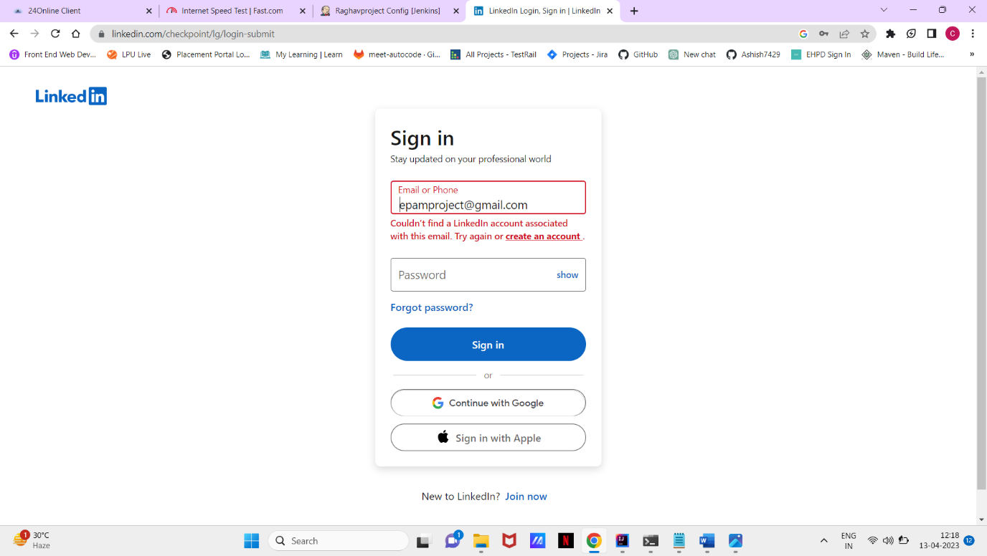

**3.** With valid credentials Test: -





**4.** Test Contact info: -





**5.** Edit Contact info Test: -



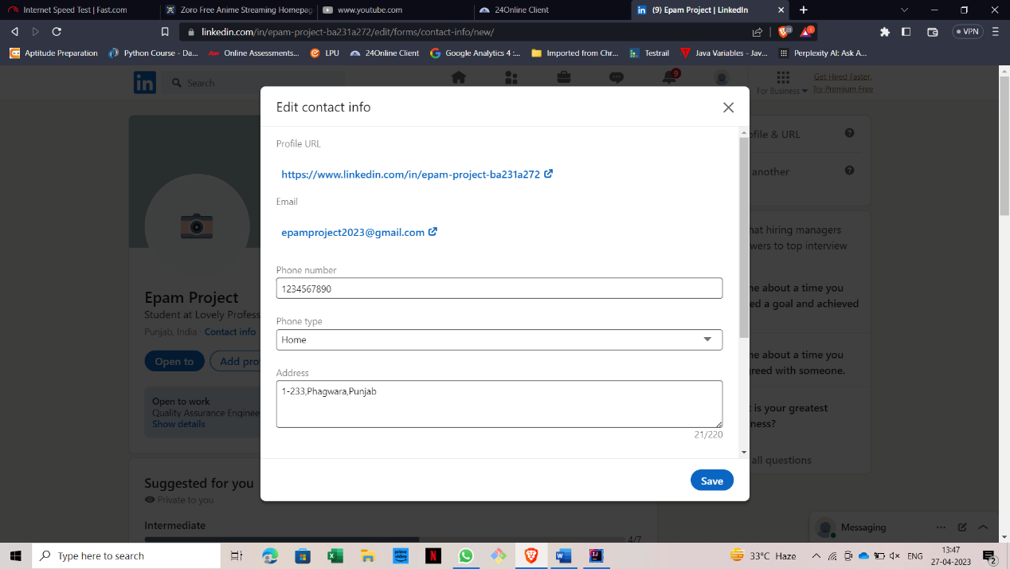

**6.** Search Box Test: -





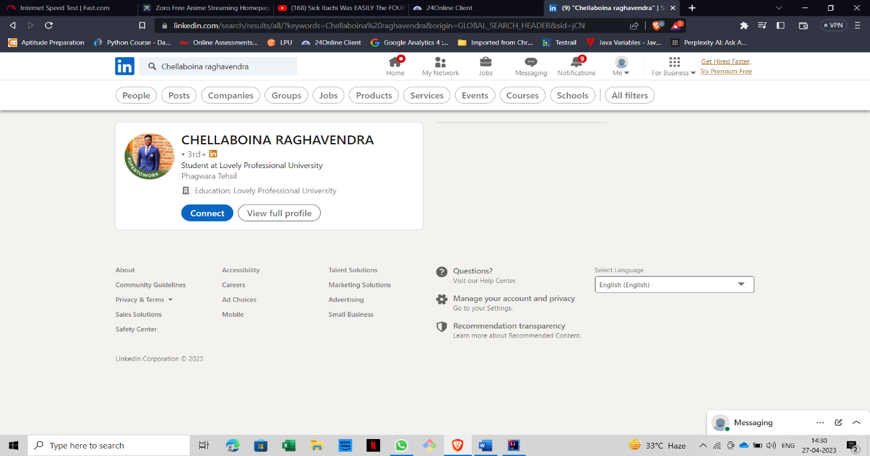

**7.** Message Test: -



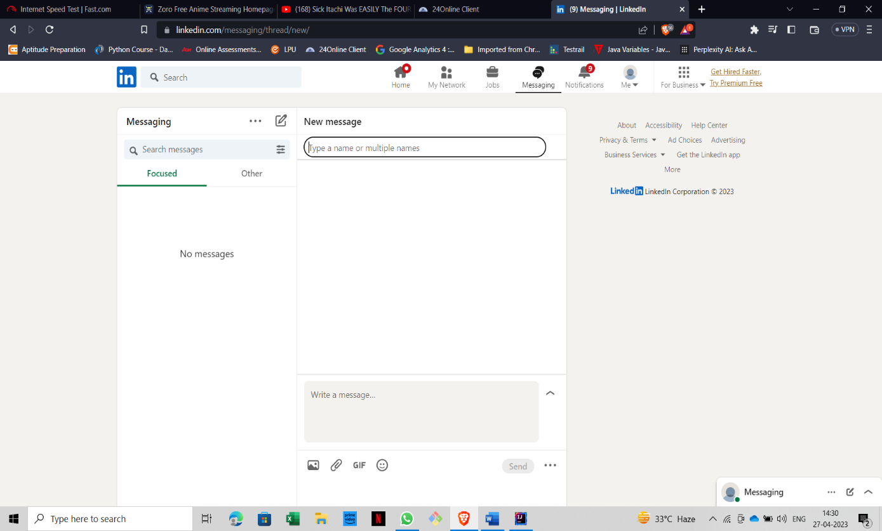

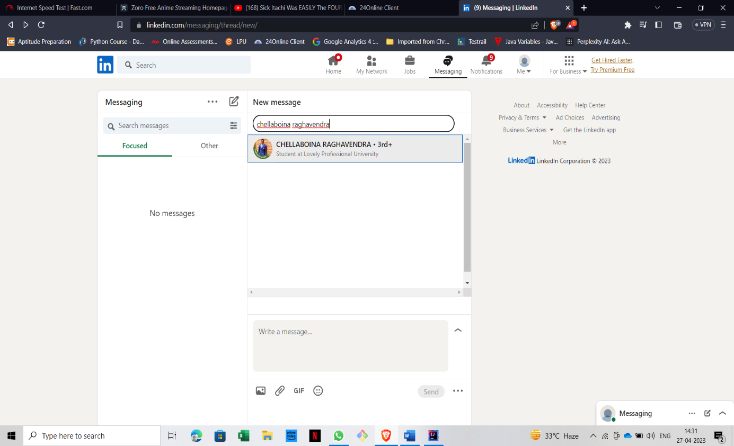

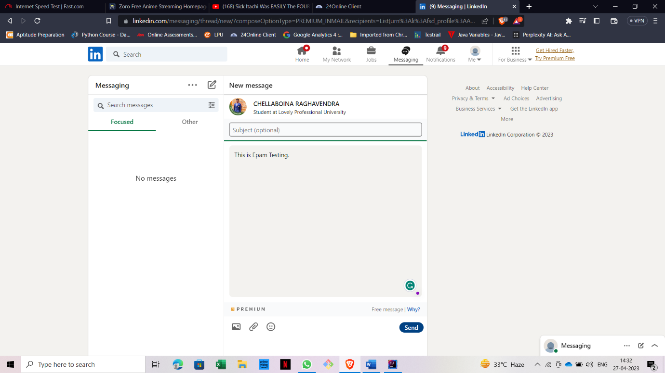

8. Delete message Test: -









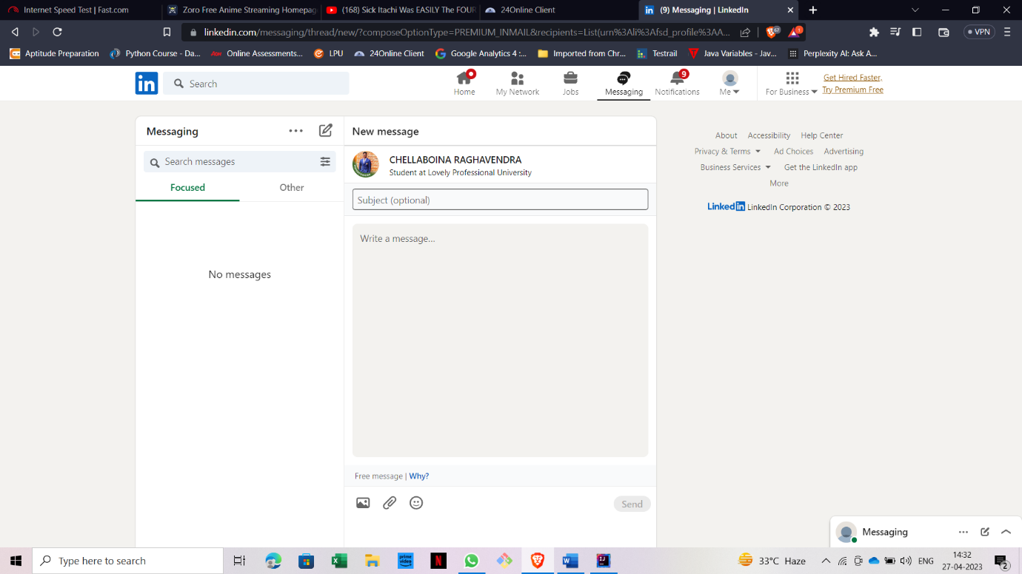

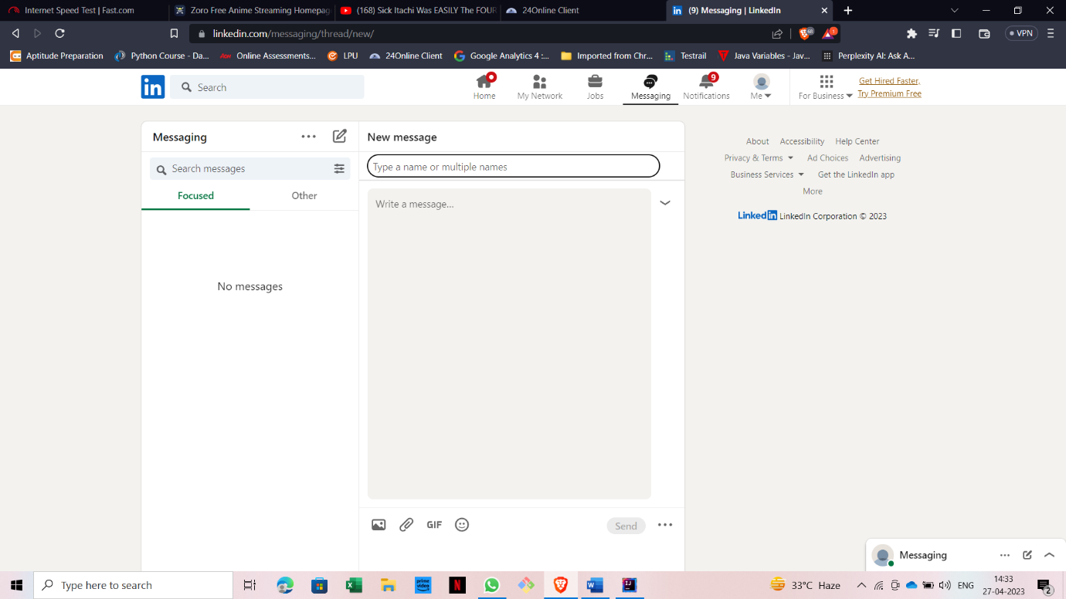

**9.** Sign out Test: -



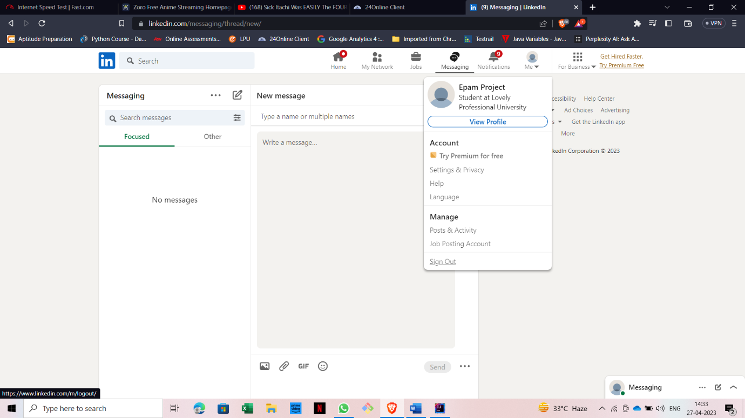



**Build run results after testing this website in Jenkins: -**

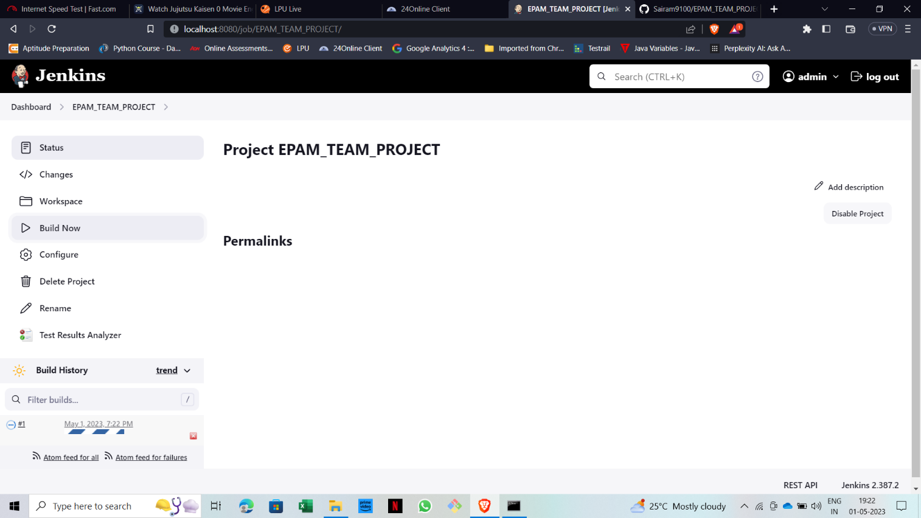

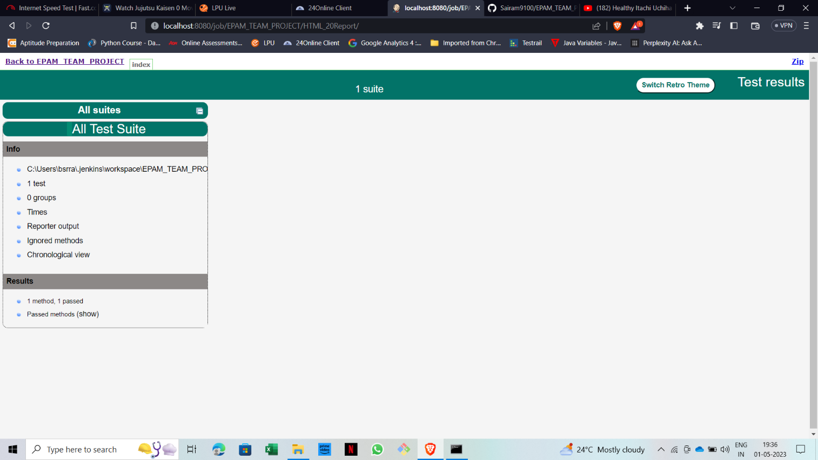

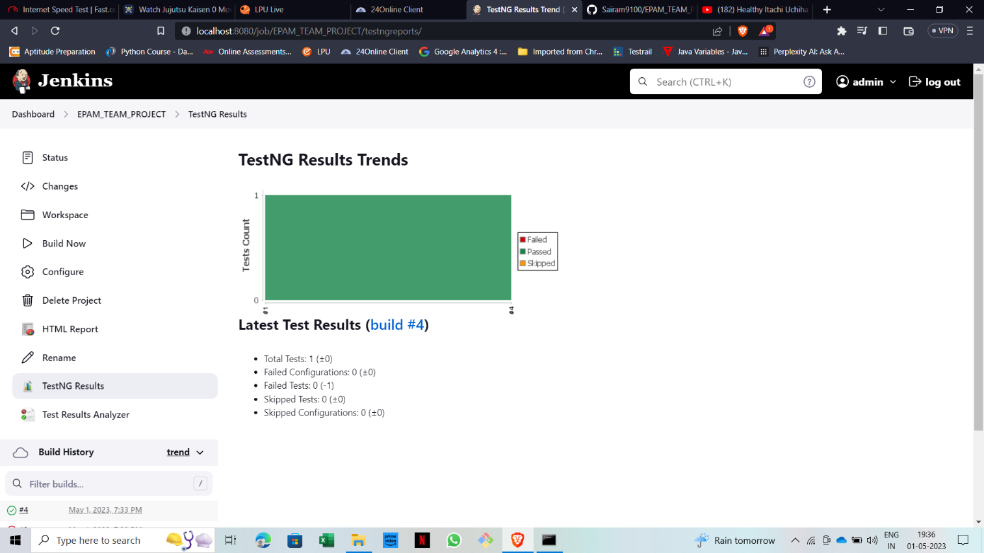

**10.RISK AND MITIGATION**

* Broken Access control
* Payment security
* Use secure passwords.

**11.REPORTING TOOL**

JENKINS is the reporting tool for the Project.

**12.TEST SUMMARY**

A Test Strategy document is created for shopping web application as per the content. It needs to be reviewing for sign-off by all entities involved in project management, business team, development team, and system administration Team.

# **Chapter-4: -**

**PROCESS UNDERGONE WHILE DOING PROJECT**

* Sign in with valid credentials.
* Click on the name.
* Click on Contact info.
* Click on Edit Icon.
* Edit Contact info and save it.
* Click on Search Box.
* Enter a profile name.
* Click On Message Icon.
* Search A profile by searching in the search bar.
* Type a message in the message box.
* Click on the send button.
* Select the checkbox of the message.
* Click on the delete icon on the above bar.
* Click on Yes, delete option on the pop-up displayed on the screen.
* To send a new message click on compose icon.
* Go to me icon and go to bottom and click on Sign Out.

# **Chapter-5: -**

## **FINAL INDIVIDIUAL TASK**

Module 1: -







Module 2: -

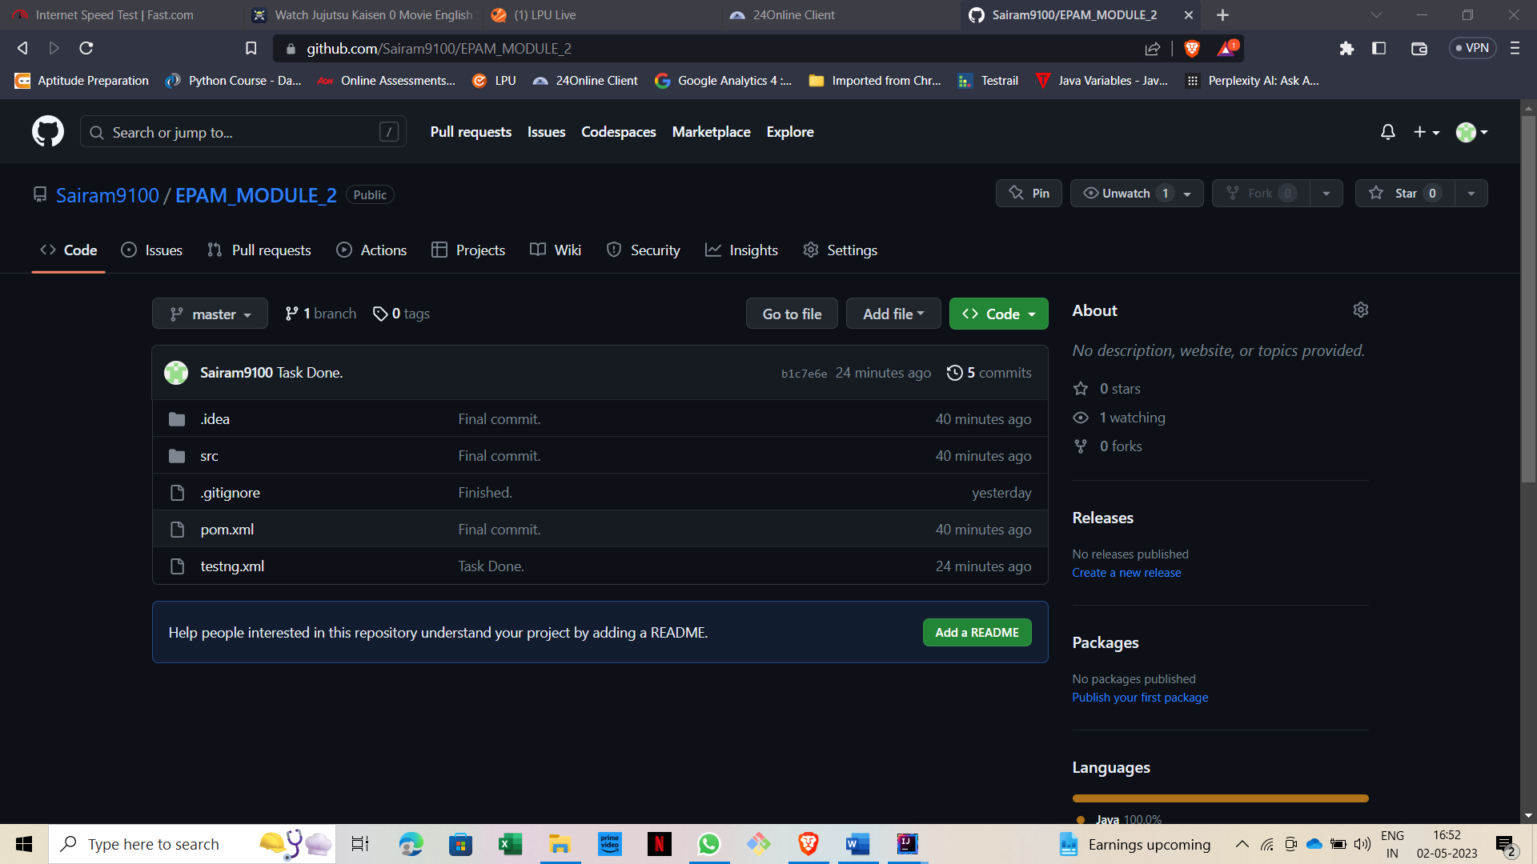

Module 3: -

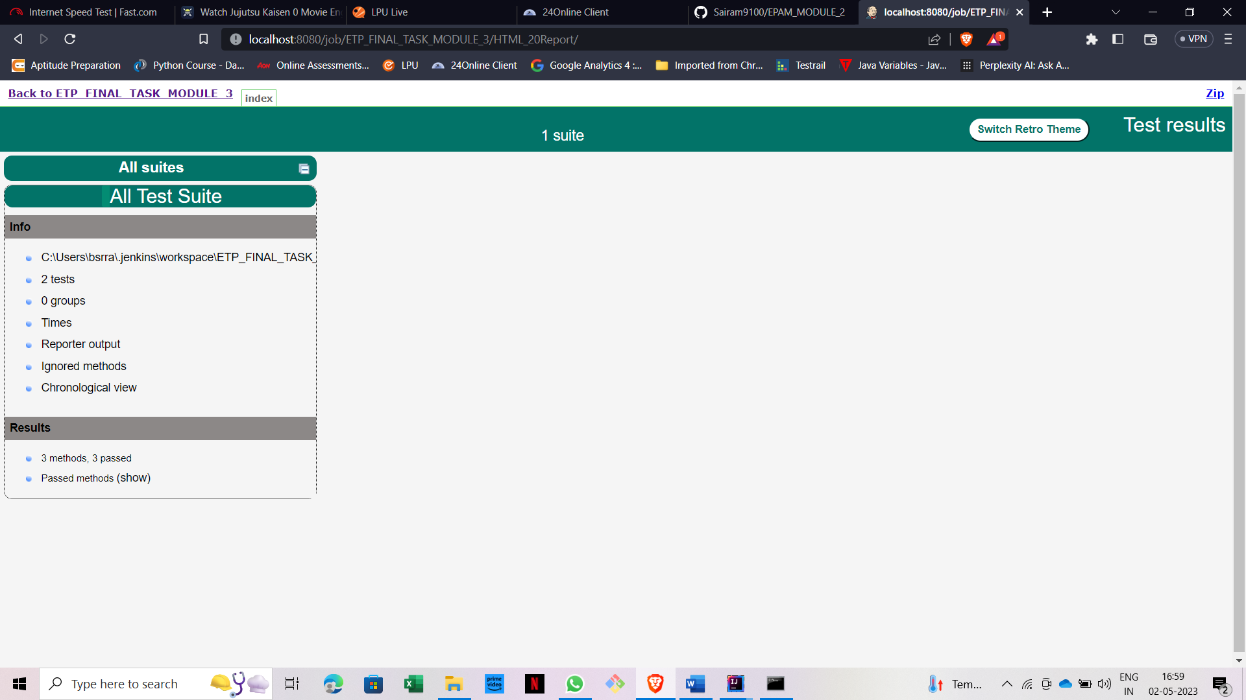

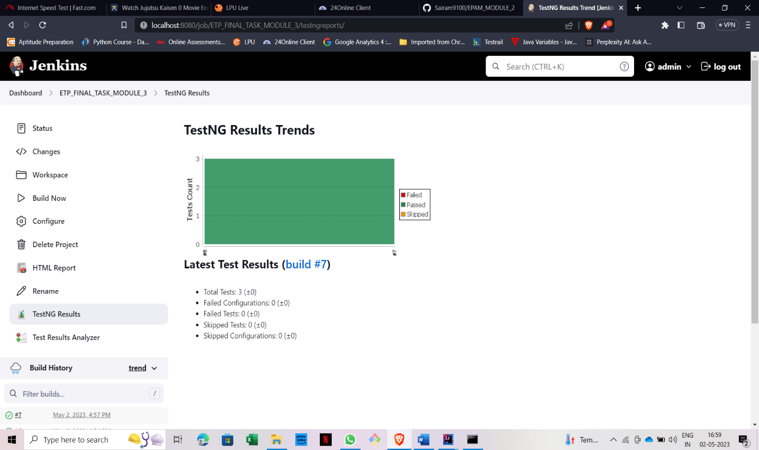

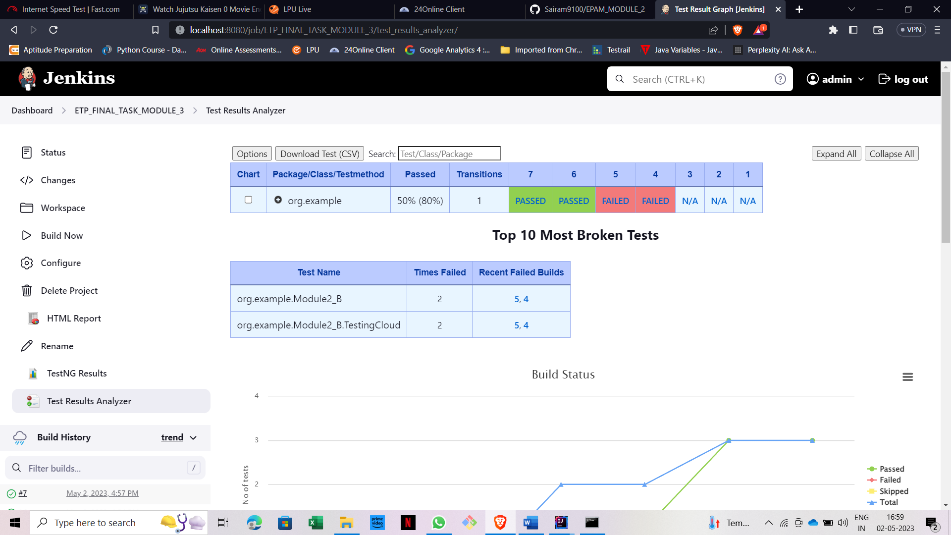

Module 4: -

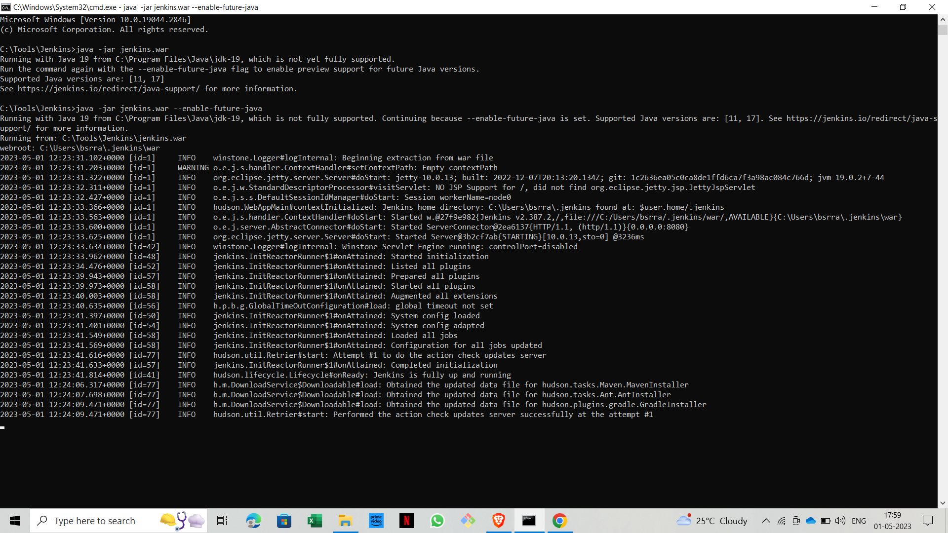

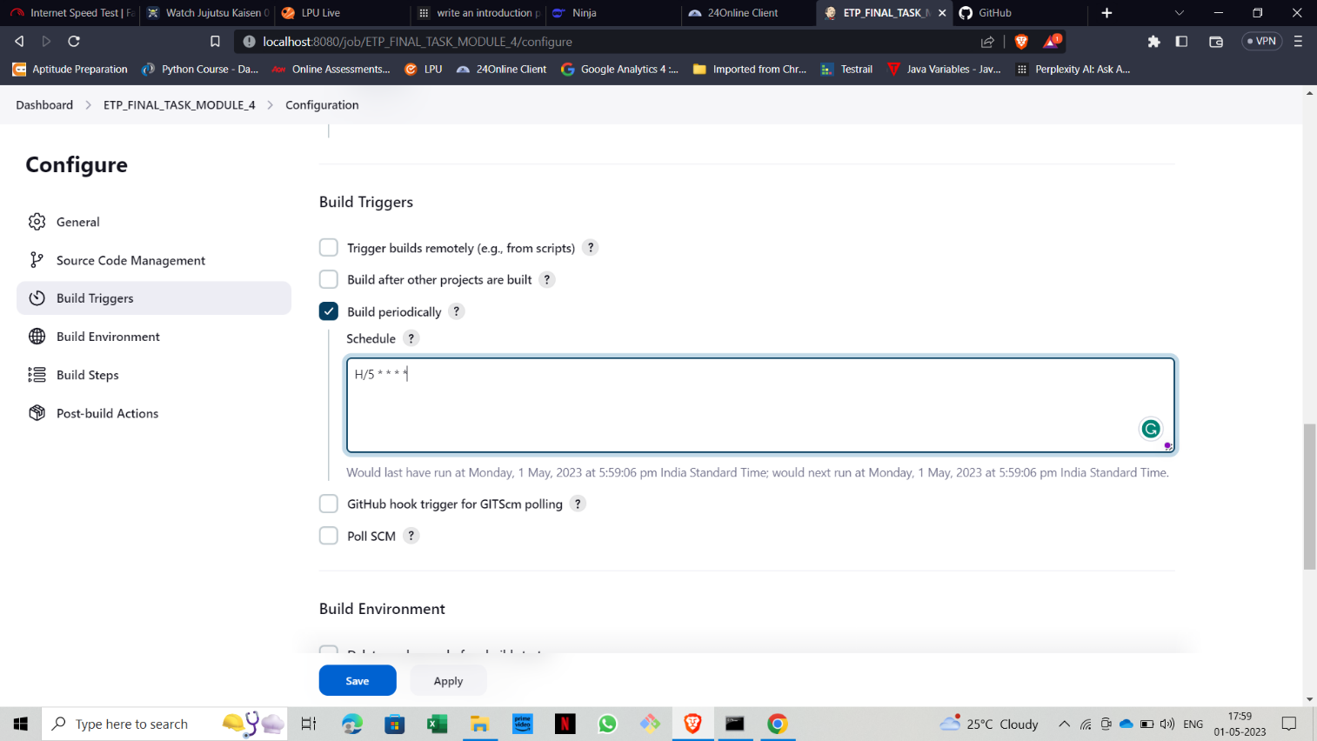

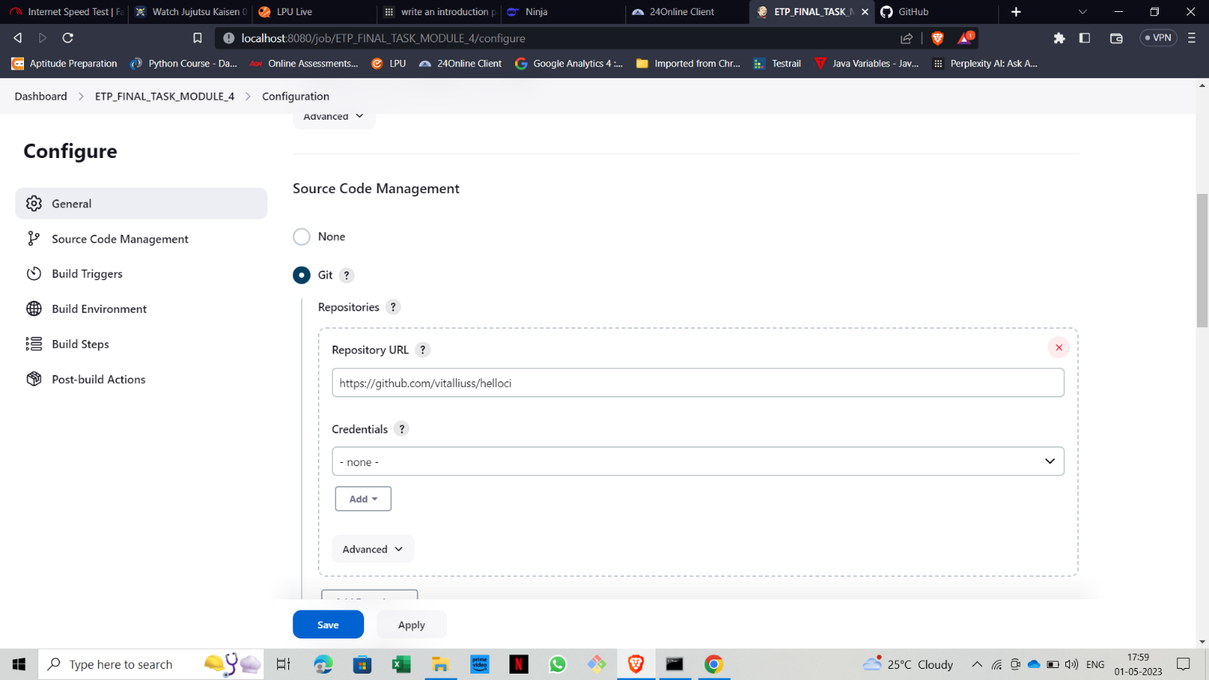

# **Chapter-6: -**

## **KNOWLWDGE AND SKILLS LEARNED IN EPAM**

**1.Selenium: -**

Software development is an essential part of almost every business in today's fast-paced world. With the increase in software development, there is a need for efficient and effective testing to ensure that the software works as expected. Automated testing has become the preferred method for testing software as it saves time, effort, and reduces the possibility of errors. In automated testing, Selenium is one of the most widely used tools. In this essay, we will discuss what Selenium is, its importance in automated testing, and how it works.

* What is Selenium?

Selenium is an open-source testing framework used for automating web applications. It was initially developed by Jason Huggins in 2004 while working at Thought Works. It is a portable testing framework that is compatible with multiple programming languages such as Java, C#, Python, Ruby, and JavaScript. Selenium consists of four components: Selenium IDE, Selenium RC, Selenium WebDriver, and Selenium Grid.

* Selenium IDE

Selenium IDE is a record and playback tool used for creating automated tests. It is a browser extension that can be used to record user interactions and generate automated test scripts. It is an easy-to-use tool that does not require any programming knowledge.

* Selenium RC

Selenium Remote Control (RC) is an older version of Selenium. It is a server that allows tests to be run on different machines and browsers. Selenium RC requires a programming language to write test scripts.

* Selenium WebDriver

Selenium WebDriver is the most commonly used component of Selenium. It is a tool used for automating web applications. It provides a programming interface to create and run test cases. WebDriver is a powerful tool that allows developers to write complex test scripts using a programming language.

* Selenium Grid

Selenium Grid is a tool used for running tests in parallel. It is used for executing tests on multiple machines and browsers simultaneously. Selenium Grid allows developers to test their web applications on different platforms and browsers.

* Why Selenium is important in Automated Testing?

Selenium is a widely used tool in automated testing due to several reasons:

* Open-Source

Selenium is an open-source tool, which means it is free to use and distribute. It is a cost-effective solution for automated testing, which is especially important for small businesses and startups.

* Cross-Browser Compatibility

Selenium supports multiple web browsers such as Chrome, Firefox, Safari, and Internet Explorer. This means that the same test script can be run on multiple browsers, making it easier to ensure that the application works as expected across different browsers.

* Multi-Language Support

Selenium supports multiple programming languages, including Java, C#, Python, Ruby, and JavaScript. This allows developers to use the programming language they are most comfortable with to write test scripts.

* Easy to Use

Selenium is an easy-to-use tool that does not require any programming knowledge to create simple test cases. Selenium IDE is a record and playback tool that can be used to create test cases without any programming knowledge.

* Scalable

Selenium Grid allows developers to run tests in parallel, making it possible to test web applications on multiple machines and browsers simultaneously. This makes it easier to scale testing as the application grows.

* How Selenium Works?

Selenium works by interacting with web elements on a web page. It can perform actions such as clicking on buttons, entering text into text fields, and navigating between pages. Selenium uses locators to identify web elements on a web page. A locator is a way of identifying a web element on a web page.

Selenium provides several types of locators:

* ID Locator

The ID locator is used to identify a web element using its ID attribute. It is the fastest and most reliable way of identifying web elements.

* Name Locator

The Name locator is used to identify a web element using its name attribute. It is useful when the web page contains multiple elements with the same name attribute.

* Class Name Locator

The Class Name locator is used to identify a web element using its class attribute. It is useful when the web page contains multiple elements with the same class attribute.

* Tag Name Locator

The Tag Name locator is used to identify a web element using its HTML tag name. It is useful when the web page contains multiple elements with the same tag name.

* Link Text Locator

The Link Text locator is used to identify a web element using the text of a link. It is useful for identifying links on a web page.

* Partial Link Text Locator

The Partial Link Text locator is used to identify a web element using a partial text of a link. It is useful when the link text is too long to be identified using the Link Text locator. Selenium WebDriver uses these locators to identify web elements on a web page. Once a web element is identified, Selenium can perform actions on it, such as clicking on a button or entering text into a text field. Selenium

Selenium WebDriver also provides methods for waiting for a web element to appear on a web page before performing an action on it. This is important because web pages can take time to load, and it is important to ensure that the web element is present on the page before performing an action on it.

Selenium WebDriver supports multiple web browsers, including Chrome, Firefox, Safari, and Internet Explorer. Each web browser requires a driver that communicates with the browser to perform actions on the web page. Selenium WebDriver provides drivers for each supported web browser, which can be downloaded and used in test scripts.

**2.Maven: -**

Maven is a popular build automation tool for Java-based projects. It is designed to simplify the build process and manage dependencies for Java projects. In the context of automated testing, Maven can be used to manage test dependencies, run tests, generate test reports, and integrate with continuous integration tools. This essay will explore the role of Maven in automated testing and how it can improve the efficiency and effectiveness of the testing process.

Managing Dependencies: -

One of the key features of Maven is its ability to manage project dependencies. In the context of automated testing, this is particularly useful as test frameworks and libraries often have dependencies on other libraries or frameworks. By using Maven to manage these dependencies, developers can ensure that all necessary libraries are included in the project and can be easily updated or added as needed. Maven uses a centralized repository system to store and manage dependencies, making it easy to access and download dependencies from the web.

Running Tests: -

Maven provides a simple way to run tests using its test plugin. The plugin allows developers to specify which tests to run and how to run them. Tests can be run as part of the build process, making it easy to run tests automatically whenever code changes are made. This can help to identify issues early in the development process, reducing the risk of introducing bugs into the codebase.

Generating Test Reports: -

Maven provides a variety of reporting plugins that can be used to generate reports on test results. These reports can provide valuable information on test coverage, performance, and test failures. The Surefire plugin, for example, generates a report on test results, including the number of tests run, the number of failures, and the time taken to run the tests. This information can help developers identify areas of the codebase that require more testing or optimization.

Integrating with Continuous Integration: -

Maven is often used in conjunction with continuous integration (CI) tools such as Jenkins, Travis CI, or GitLab CI/CD. CI tools automate the build and testing process, running tests automatically whenever changes are made to the codebase. Maven provides an easy way to integrate with these tools, allowing developers to run tests automatically as part of the build process. This can help to identify issues early in the development process, reduce the time and effort required for manual testing, and ensure that code changes are thoroughly tested before being deployed to production.

Maven is a powerful tool for managing dependencies, running tests, generating test reports, and integrating with CI tools. In the context of automated testing, Maven can improve the efficiency and effectiveness of the testing process by automating the testing process, identifying issues early in the development process, and generating valuable reports on test results. By using Maven to manage test dependencies, run tests, and generate test reports, developers can ensure that code changes are thoroughly tested and validated before being deployed to production, reducing the risk of errors in code.

**3.Jenkins: -**

Jenkins is an open-source automation tool that is widely used for continuous integration (CI) and continuous delivery (CD) of software projects. It automates the building, testing, and deployment of software projects, allowing developers to focus on writing code and improving the quality of their software. In the context of automated testing, Jenkins is a powerful tool that can be used to automate the testing process, integrate with testing frameworks, and generate test reports. This essay will explore the role of Jenkins in automated testing and how it can improve the efficiency and effectiveness of the testing process.

Automating Testing Process: -

Jenkins can automate the testing process by allowing developers to schedule automated tests to run at regular intervals or on specific events, such as code changes or new releases. Jenkins can be integrated with various testing frameworks, including Selenium, JUnit, TestNG, and Cucumber. This allows developers to automate unit testing, integration testing, functional testing, and acceptance testing. By automating the testing process, developers can identify issues early in the development process, reduce the time and effort required for manual testing, and ensure that code changes are thoroughly tested before being deployed to production.

Integrating with Testing Frameworks: -

Jenkins can be easily integrated with testing frameworks, making it easy for developers to run tests as part of the build process. This integration can be achieved through plugins or by configuring build scripts in Jenkins. For example, the Selenium plugin for Jenkins can be used to run Selenium tests as part of the build process, making it easy to ensure that all tests are executed whenever changes are made to the codebase. Similarly, the JUnit plugin can be used to run JUnit tests, and the TestNG plugin can be used to run TestNG tests. By integrating with testing frameworks, Jenkins can provide valuable information on test results, including test coverage, test failures, and test execution time.

Generating Test Reports: -

Jenkins can generate reports on test results, providing valuable information on the quality of the software being developed. Jenkins provides several plugins that can be used to generate test reports, including the JUnit plugin, the TestNG plugin, and the Cucumber plugin. These reports can be customized to provide detailed information on test coverage, test execution time, and test failures. By generating test reports, developers can identify areas of the codebase that require more testing, ensuring that code changes are thoroughly tested before being deployed to production.

Integrating with Version Control Systems: -

Jenkins can be easily integrated with version control systems, such as Git, Subversion, and Mercurial. This integration allows developers to automate the building, testing, and deployment of software projects whenever changes are made to the codebase. Jenkins can be configured to automatically detect changes in the codebase and initiate the build and testing process. By integrating with version control systems, Jenkins can ensure that code changes are thoroughly tested before being deployed to production, reducing the risk of introducing bugs into the codebase.

Jenkins is a powerful automation tool that can be used to automate the testing process, integrate with testing frameworks, generate test reports, and integrate with version control systems. In the context of automated testing, Jenkins can improve the efficiency and effectiveness of the testing process by automating the testing process, identifying issues early in the development process, and generating valuable reports on test results. By integrating with testing frameworks and version control systems, Jenkins can ensure that code changes are thoroughly tested before being deployed to production, reducing the risk of introducing bugs into the codebase. Overall, Jenkins is an essential tool for any software project and should be considered an integral part of any automated testing strategy.

# **Chapter-7: -**

# **Conclusion**

In conclusion, the use of automated testing tools such as Selenium, Maven, and Jenkins have proven to be highly effective in testing the LinkedIn website. These tools have enabled us to automate the testing process, significantly reduce manual effort, and ensure high quality software development.

Selenium, as a widely used open-source web automation tool, has enabled us to execute a range of automated tests. The Selenium web driver allows us to interact with the website’s user interface and simulate various user interactions. The ability to automate these tests has significantly reduced the overall testing time and the likelihood of manual errors. This has enabled us to improve the efficiency of the testing process and to ensure comprehensive testing coverage of the LinkedIn website.

Maven, as a powerful project management tool, has allowed us to manage the testing process effectively. It has enabled us to define dependencies, run tests automatically, and configure the build process with ease. Maven also provided us with a clean way of setting up and maintaining the testing environment. This has allowed us to have greater control over the testing process and to achieve a high level of consistency in the testing environment.

Jenkins, as a continuous integration and delivery tool, has been an essential component of the testing process. It has provided us with a platform to automate the testing process, manage test executions, and generate valuable reports on test results. The ability to integrate Jenkins with Selenium and Maven has allowed us to create a powerful and scalable testing pipeline. We were able to trigger tests automatically whenever changes were made to the codebase, ensuring that all changes were thoroughly tested before being deployed to production.

The combination of Selenium, Maven, and Jenkins has allowed us to improve the quality of the LinkedIn website significantly. Automated testing has enabled us to identify issues early in the development cycle, reducing the overall cost of fixing bugs and improving the overall quality of the website. The integration of these tools has also allowed us to achieve a high degree of testing coverage, ensuring that all components of the website are thoroughly tested.

In addition to the benefits of the automated testing process, there are other advantages of using Selenium, Maven, and Jenkins in the development cycle. These tools are open source, meaning that they are accessible and cost-effective. The community support for these tools is also extensive, which allows for easy troubleshooting and customization.

Additionally, the ability to integrate these tools with other software development tools such as version control systems and issue tracking software further enhances their value in the development cycle.

In conclusion, the use of Selenium, Maven, and Jenkins has proven to be a highly effective testing solution for the LinkedIn website. The use of these tools has enabled us to automate the testing process, increase efficiency, and improve the overall quality of the website. The integration of these tools has also allowed us to create a powerful and scalable testing pipeline. As the software development industry continues to evolve, it is essential to adopt these testing tools to ensure high quality software development. The use of Selenium, Maven, and Jenkins has allowed us to achieve these goals and will undoubtedly continue to play a crucial role in the future of software development.